**ASSIGNMENT-4**

**BRIEF COMPARISON**

|  |  |  |  |  |  |  |  |
| --- | --- | --- | --- | --- | --- | --- | --- |
|  | **Google Cloud Engine** | **AWS** | **Azure** | **Salesforce** | **IBM Cloud** | **Rackspace** | **SAP HANA** |
| **Service Model** | Iaas | Paas | Iaas | Paas | Iaas | Iaas | Paas |
| **Deployment model** | Public | Public | Public | Public | Private, Hybrid | Public, Private, Hybrid | Public |
| **Server OS** | Windows, Linux | Windows | Windows, Linux | Windows, Linux | Windows, Linux | Windows, Linux | Linux |

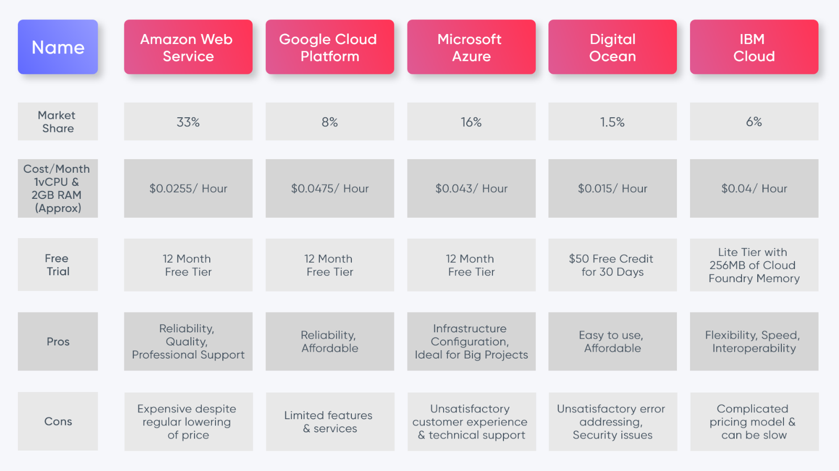

**DETAILED COMPARISON**

1. **EMC**

Dell EMC sells [data storage](https://en.wikipedia.org/wiki/Data_storage_device), [information security](https://en.wikipedia.org/wiki/Information_security), [virtualization](https://en.wikipedia.org/wiki/Virtualization), analytics, [cloud computing](https://en.wikipedia.org/wiki/Cloud_computing) and other products and services that enable organizations to store, manage, protect, and analyse data. Dell EMC's target markets include large companies and small- and medium-sized [businesses](https://en.wikipedia.org/wiki/Business) across various vertical markets.

Services provided by EMC

|  |  |
| --- | --- |
| **Product category** | **Products/Services** |
| Information [Storage](https://en.wikipedia.org/wiki/Data_storage_device) | PowerMax, [VMAX Family](https://en.wikipedia.org/wiki/Dell_EMC_VMAX), VNX/VNXe Family, [Isilon](https://en.wikipedia.org/wiki/Isilon), [Atmos](https://en.wikipedia.org/wiki/EMC_Atmos), [XtremIO](https://en.wikipedia.org/wiki/Dell_EMC_XtremIO), ScaleIO, Unity/Unity XT Family, PowerStore, [ECS](https://en.wikipedia.org/wiki/EMC_Elastic_Cloud_Storage) |
| [Archiving](https://en.wikipedia.org/wiki/Data_archive#Electronic_archiving), [Backup](https://en.wikipedia.org/wiki/Backup), and [Recovery](https://en.wikipedia.org/wiki/Data_recovery) | Avamar, [DataDomain](https://en.wikipedia.org/wiki/Data_Domain_(corporation)" \o "Data Domain (corporation)), [NetWorker](https://en.wikipedia.org/wiki/EMC_NetWorker" \o "EMC NetWorker), [RecoverPoint](https://en.wikipedia.org/wiki/RecoverPoint), Centera, SourceOne |
| Storage and Content Management | Service Assurance Suite, Appsync, PowerPath, ViPR SRM, [ViPR Controller](https://en.wikipedia.org/wiki/EMC_ViPR" \o "EMC ViPR) |
| [Virtualization](https://en.wikipedia.org/wiki/Hardware_virtualization) | [VMware](https://en.wikipedia.org/wiki/VMware), [VPLEX](https://en.wikipedia.org/wiki/VPLEX) |
| [Services](https://en.wikipedia.org/wiki/IT_services) | [Consulting](https://en.wikipedia.org/wiki/Technology_consulting), [Customer support](https://en.wikipedia.org/wiki/Customer_support), Education Services, Managed Services, Technology Services and Solutions |
| [Security](https://en.wikipedia.org/wiki/Information_security)/Compliance | [RSA Security](https://en.wikipedia.org/wiki/RSA_Security), [Dell SecureWorks](https://en.wikipedia.org/wiki/Dell_SecureWorks) |
| [Cloud computing](https://en.wikipedia.org/wiki/Cloud_computing)/Converged Infrastructure | VxBlock, VxRack, VxRail, VSPEX, Virtustream |
| Data Computing | [Greenplum](https://en.wikipedia.org/wiki/Greenplum), Pivotal |

**2.AWS**

**Amazon Web Services, Inc.** (**AWS**) is a subsidiary of [Amazon](https://en.wikipedia.org/wiki/Amazon.com) that provides [on-demand](https://en.wikipedia.org/wiki/Software_as_a_service) [cloud computing](https://en.wikipedia.org/wiki/Cloud_computing) [platforms](https://en.wikipedia.org/wiki/Computing_platform) and [APIs](https://en.wikipedia.org/wiki/Application_programming_interface) to individuals, companies, and governments, on a metered pay-as-you-go basis. These cloud computing [web services](https://en.wikipedia.org/wiki/Web_services) provide [distributed computing](https://en.wikipedia.org/wiki/Distributed_computing) processing capacity and software tools via AWS [server farms](https://en.wikipedia.org/wiki/Server_farms).

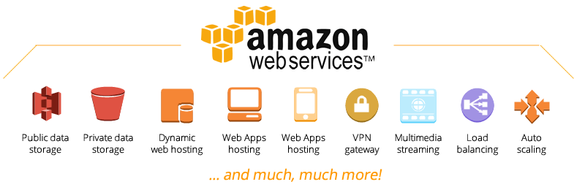

Figure 1 : Amazon Web Services

Amazon EC2

An AWS service that allows us to create virtual machines and manage other features of servers; such as storage, security, ports, etc. With Amazon EC2 you can create servers in minutes with your preferred operating system.

This way you will have more time to take care of your projects and spend less time maintaining your servers.

Amazon RDS

Amazon helps us to make our infrastructure less complicated, which is why it provides us with the RDS service. But what is it? With this service we will have dedicated instances for databases in a matter of minutes, fully managed by the AWS support team and capable of supporting multiple database engines such as SQL, PostgreSQL, SQL Server, etc.

Amazon Simple Storage Service (S3)

Amazon S3 gives us relief when we talk about data, because they have an incredibly secure infrastructure. In addition to intelligently distributing data in different physical regions, they also have integrations such as PCI-DSS, HIPAA / HITECH, FedRAMP, our data will never be compromised.

AWS S3 also has high availability, so accessing your information is just a click away, with almost zero latency of 99.9999999999%. Surely now you wonder how expensive this service is? Well, we are pleased to inform you that it is impressively cheap. First, it has a free layer that includes 5 GB of storage and then starts at the cost of $ 0.023 / month for the first 50TB. Continue reading about [AWS S3 pricing](https://www.clickittech.com/amazon-s3/aws-s3-pricing/)!

Amazon Cloudfront

Amazon is responsible for managing all your content, delivering it and presenting it efficiently. With a minimum latency and with its high integration with other AWS services. Reaching your target users has never been so easy.

Amazon VPC

In the private network in the cloud your information will only be available to the people or systems that you authorize. With AWS VPC you can create a private virtual network in which your entire IT environment (infrastructure or services) will live totally isolated from the outside world. This way your information is free of exposure.

Amazon SNS

Going back to the developers’ issue, AWS services list offers us a very particular notification system that provides integration with any type of application, be it PHP, Python, Node, etc. With Amazon SNS we can send notifications to all our users on any platform, whether it is web or mobile on Android or iOS.

AWS Beanstalk

This is the most attractive service for developers. I know that as a developer you do not want to manage the infrastructure of your site, right? It is normal since its maintenance becomes tedious and difficult to solve any problem. AWS Elastic Beanstalk relieves all this; developers no longer need to manage the infrastructure and focus on developing their software or applications.

AWS Lambda

Is your server saturated with many requests? You do not know what to do? Stop worrying too much about infrastructure and less about development.

If you, like many other developers, have the problem that your current infrastructure does not support the demands of your developments, then [AWS Lambda](https://i9.ytimg.com/vi_webp/lqXMi5h2Z0c/mqdefault.webp?time=1621530600000&sqp=COivmoUG&rs=AOn4CLDq8s3_UuOMjB42y4wjG0FJXAcgFg) is for you. This instance allows you to work in an environment highly capable of supporting any development you do. You just take care of the coding and AWS will be responsible for providing the necessary resources, climbing at the same time so that everything works correctly.

AWS Autoscaling

**The magic of AWS**– How to expand our application and take it to thousands and millions of users?

Well, Amazon again gives us the solution. With AutoScaling we can manage a fleet of servers which are capable of supporting all the traffic that our application demands. The service is totally free, the only thing charged is the number of instances for the time they run.

AWS Elastic Cache

Memory caching system of AWS. Elasticache supports Memcache and Redis.

“Now that you have what it takes do not think more and venture to create extraordinary things with AWS and ClickIT.”

This is not a full AWS services list; AWS has many more services that surely fit perfectly with your projects. That’s why we decided to make this list that we hope you find useful or we think are necessary for your infrastructure. Our primary objective is to help our clients to know and integrate new technologies, and we can keep moving forward together. Contact us anytime you need something related to our [AWS services](https://www.clickittech.com/aws-managed-services/)!

**3.Google**

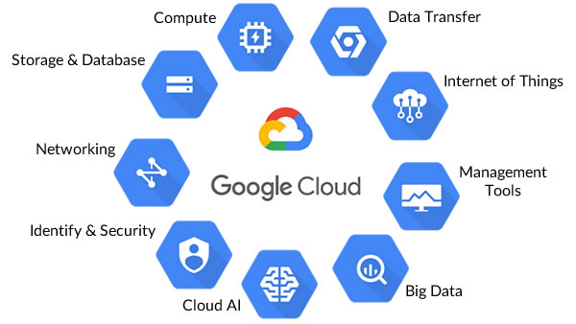

**Compute**

* [**Compute Engine**](https://cloud.google.com/compute/): An [IaaS](https://en.wikipedia.org/wiki/Cloud_computing#Infrastructure_as_a_service_.28IaaS.29) service that provides [virtual machines](https://en.wikipedia.org/wiki/Virtual_machine) (VMs) hosted on Google’s infrastructure. Competitor services include [Amazon Elastic Compute Cloud](https://en.wikipedia.org/wiki/Amazon_Elastic_Compute_Cloud), and on-premises equivalents such as [OpenStack](https://en.wikipedia.org/wiki/OpenStack).
* [**App Engine**](https://cloud.google.com/appengine/): A [PaaS](https://en.wikipedia.org/wiki/Cloud_computing#Platform_as_a_service_.28PaaS.29) service for building web applications and mobile backends using container instances preconfigured with one of [several available runtimes](https://cloud.google.com/appengine/docs/about-the-standard-environment), each of which include a set of standard App Engine libraries. Competitor services include [Amazon Elastic Beanstalk](https://en.wikipedia.org/wiki/AWS_Elastic_Beanstalk) and [Microsoft Azure Web Sites](https://en.wikipedia.org/wiki/Microsoft_Azure_Web_Sites).
* [**Container Engine**](https://cloud.google.com/container-engine/): Cluster management and orchestration system for coordinating [Docker](https://www.docker.com/) containers. It is based on the open source [Kubernetes](https://kubernetes.io/) project.
* [**Container Registry**](https://cloud.google.com/container-registry): Private [Docker](https://en.wikipedia.org/wiki/Docker_(software)) repository hosted on Google’s infrastructure.
* [**Cloud Functions**](https://cloud.google.com/functions/): An event-based, asynchronous compute solution that allows you to create [microservices](https://en.wikipedia.org/wiki/Microservices) (small, single-purpose functions) that respond to cloud events without requiring an explicitly managed server or a runtime environment. Google Cloud Functions has been in Alpha [since February 2016](http://venturebeat.com/2016/02/09/google-has-quietly-launched-its-answer-to-aws-lambda/).
* [**Cloud Pub/Sub**](https://cloud.google.com/pubsub): A fully-managed real-time messaging service for sending and receiving messages between independent applications.
* [**Cloud Endpoints Frameworks for App Engine**](https://cloud.google.com/appengine/docs/java/endpoints/): Used to create [RESTful](https://en.wikipedia.org/wiki/Representational_state_transfer) services from your code and make them accessible to [iOS](https://en.wikipedia.org/wiki/IOS), [Android](https://en.wikipedia.org/wiki/Android_(operating_system)), and [Javascript](https://en.wikipedia.org/wiki/JavaScript" \t "_blank) clients using [App Engine](https://en.wikipedia.org/wiki/Google_App_Engine). Formerly Cloud Endpoints.

**Storage and Databases**

* [**Cloud Storage**](https://cloud.google.com/storage/): A unified object storage service, offering a [spectrum of storage options](https://cloud.google.com/storage/docs/storage-classes) including geo-redundant (low-latency, high [QPS](https://en.wikipedia.org/wiki/Queries_per_second) content serving to users distributed across geographic regions), regional (for workloads in a particular region), [nearline](https://cloud.google.com/storage-nearline/nearline-whitepaper) (for data accessed less than once a month), and coldline (for data accessed less than once a year.) Competitor services include [Amazon Simple Storage Service](https://en.wikipedia.org/wiki/Amazon_S3) (geo-redundant / regional) and [Amazon Glacier](https://en.wikipedia.org/wiki/Amazon_Glacier) (coldline).
* [**Cloud SQL**](https://cloud.google.com/sql): A fully-managed [MySQL](https://en.wikipedia.org/wiki/MySQL) database service for hosting relational MySQL databases on Google’s infrastructure.
* [**Bigtable**](https://cloud.google.com/bigtable/): A high performance [NoSQL](https://en.wikipedia.org/wiki/NoSQL) [Big Data](https://en.wikipedia.org/wiki/Big_data) database service, designed to support very large workloads at consistent low latency and high throughput rates. Google [uses Bigtable internally](http://static.googleusercontent.com/media/research.google.com/en/archive/bigtable-osdi06.pdf) to power services including Search and Gmail.
* [**Cloud Datastore**](https://cloud.google.com/datastore/): A [NoSQL](https://en.wikipedia.org/wiki/NoSQL) schemaless database for storing non-relational data. It’s an alternative to [Bigtable](https://cloud.google.com/bigtable/) when [ACID](https://en.wikipedia.org/wiki/ACID) transactions are required, or the data stored is highly structured.
* [**Cloud Spanner**](https://cloud.google.com/spanner/) A managed globally distributed relational database with ACID transactions, strong consistency, SQL semantics, horizontal scaling, and high availability.
* [**Persistent Disk**](https://cloud.google.com/persistent-disk/): A service that provides SSD and HDD storage that can be attached to instances running in either [Compute Engine](https://cloud.google.com/compute/) or [Container Engine](https://cloud.google.com/container-engine/).
* [**Cloud Source Repositories**](https://cloud.google.com/source-repositories/): Private [Git](https://en.wikipedia.org/wiki/Git) repositories hosted on GCP; they are [currently in beta](http://venturebeat.com/2015/06/24/google-has-quietly-launched-a-github-competitor-source-code-repositories/).

**Big Data**

* [**BigQuery**](http://cloud.google.com/bigquery): S[erverless](https://en.wikipedia.org/wiki/Serverless_computing), fully managed, petabyte scale [data warehouse](https://en.wikipedia.org/wiki/Data_warehouse) and [analytics](https://en.wikipedia.org/wiki/Analytics) platform, used to store and query [Big Data](https://en.wikipedia.org/wiki/Big_data) using [SQL](https://en.wikipedia.org/wiki/SQL).
* [**Cloud Dataflow**](https://cloud.google.com/dataflow/): A fully-managed real-time data processing service for batch and streaming [Big Data](https://en.wikipedia.org/wiki/Big_data) processing, supporting [ETL](https://en.wikipedia.org/wiki/Extract,_transform,_load), batch computation, and continuous computation.
* [**Dataproc**](https://cloud.google.com/dataproc/):Managed [Apache Hadoop](https://en.wikipedia.org/wiki/Apache_Hadoop), [Apache Spark](https://en.wikipedia.org/wiki/Apache_Spark), [Apache Pig](https://en.wikipedia.org/wiki/Pig_(programming_tool)), and [Apache Hive](https://en.wikipedia.org/wiki/Apache_Hive) service used to process large datasets.
* [**Cloud Datalab**](https://cloud.google.com/datalab/): An interactive tool for large-scale data exploration, analysis, and visualization built on [Jupyter](https://en.wikipedia.org/wiki/IPython" \l "Project_Jupyter" \t "_blank) (formerly IPython). It supports data analysis using [BigQuery](http://cloud.google.com/bigquery" \t "_blank), [Compute Engine](https://cloud.google.com/compute/), and [Cloud Storage](https://cloud.google.com/storage) using [Python](https://en.wikipedia.org/wiki/Python_(programming_language)), [SQL](https://en.wikipedia.org/wiki/SQL), and [JavaScript](https://en.wikipedia.org/wiki/JavaScript). Cloud Datalab is in [open Beta](https://techcrunch.com/2015/10/13/google-launches-cloud-datalab-an-interactive-tool-for-exploring-and-visualizing-data/).
* [**Google Genomics**](https://cloud.google.com/genomics/overview): An API to store, process, explore and share [genomics](https://en.wikipedia.org/wiki/Genomics) data using the standards defined by the [Global Alliance for Genomics and Health](https://www.genomeweb.com/informatics/google-joins-global-alliance-genomics-and-health). That includes support for managing datasets, reads and variants; searching and slicing; and setting access control for sharing.

**Machine Learning**

* [**Cloud Machine Learning**](https://cloud.google.com/products/machine-learning/): A managed service for building [machine learning](https://en.wikipedia.org/wiki/Machine_learning) models using the [TensorFlow](https://www.tensorflow.org/) framework.
* The [**Cloud Vision API**](https://cloud.google.com/vision/): A [REST](https://en.wikipedia.org/wiki/Representational_state_transfer) API that can be used to understand the content of an image into categories, detect individual objects and faces within images, and find and read printed words contained within images[¹](https://techcrunch.com/2016/02/18/google-opens-its-cloud-vision-api-to-all-developers/).
* The [**Cloud Speech API**](https://cloud.google.com/speech/): A [REST](https://en.wikipedia.org/wiki/Representational_state_transfer) API that can be used to convert audio to text. The API recognizes over [80 languages](https://cloud.google.com/speech/docs/languages) and variants. The Google Cloud Speech API is [currently in open Beta](https://techcrunch.com/2016/03/23/google-opens-access-to-its-speech-recognition-api-going-head-to-head-with-nuance/).
* The [**Natural Language API**](https://cloud.google.com/natural-language/): A [REST](https://en.wikipedia.org/wiki/Representational_state_transfer) API that can be used to parse the structure and meaning of text. It can extract information including the people, places, events, and sentiment within a provided text. The Google Cloud Natural Language API is [currently in open Beta](https://techcrunch.com/2016/07/20/google-launches-new-api-to-help-you-parse-natural-language/).
* The [**Translate API**](https://cloud.google.com/translate/): A [REST](https://en.wikipedia.org/wiki/Representational_state_transfer) API that can be used to translate an arbitrary language string into any supported language. [Language identification](https://cloud.google.com/translate/docs/detecting-language) is available for cases where the source language is unknown.

**Networking**

* [**Google Cloud Virtual Network**](https://cloud.google.com/compute/docs/networking): A set of Google-managed networking capabilities, including granular IP address range selection, [routes](https://en.wikipedia.org/wiki/Routing_table), [firewalls](https://en.wikipedia.org/wiki/Firewall_(computing)), [Virtual Private Network](https://en.wikipedia.org/wiki/Virtual_private_network) (VPN) and Cloud Router for provisioning your GCP resources, connecting them to each other and isolating them from one another in a [Virtual Private Cloud](https://gigaom.com/2014/11/04/google-cloud-goes-corporate-with-peering-carrier-interconnects-vpn/) (VPC).
* [**Cloud Load Balancing**](https://cloud.google.com/compute/docs/load-balancing-and-autoscaling): A service that [load-balances](https://en.wikipedia.org/wiki/Load_balancing_(computing)) and [auto-scales](https://en.wikipedia.org/wiki/Autoscaling) GCP compute resources in single or multiple regions behind a single [anycast](https://en.wikipedia.org/wiki/Anycast) IP[²](http://research.google.com/pubs/pub44824.html).
* [**Cloud CDN**](https://cloud.google.com/cdn/): Uses Google’s globally distributed edge [points of presence](https://peering.google.com/#/infrastructure) to cache HTTP(S) [load-balanced](https://en.wikipedia.org/wiki/Load_balancing_(computing)) content close to users.
* [**Google Cloud Interconnect**](https://cloud.google.com/interconnect/docs): Allows GCP customers to connect to Google via higher availability and/or lower latency connections than their existing Internet connections.
* [**Cloud DNS**](https://cloud.google.com/dns/docs/): A managed authoritative [Domain Name System](https://en.wikipedia.org/wiki/Domain_Name_System) (DNS) service running on the same infrastructure as Google. Cloud DNS translates requests for [domain names](https://en.wikipedia.org/wiki/Domain_name) into [IP addresses](https://en.wikipedia.org/wiki/IP_address) and offers a UI, command-line interface, and API for publishing and managing millions of [DNS zones](https://en.wikipedia.org/wiki/DNS_zone) and [resource records](https://en.wikipedia.org/wiki/Domain_Name_System#DNS_resource_records).

**Identity and Security**

* [**Google Cloud IAM:**](https://cloud.google.com/iam/)Lets [administrators](https://en.wikipedia.org/wiki/System_administrator) authorize who can take action on specific resources, along with built-in [auditing](https://en.wikipedia.org/wiki/Information_technology_audit) [³](http://venturebeat.com/2016/03/23/google-cloud-platform-now-offers-identity-and-access-management-roles-for-users/).
* [**Cloud Resource Manager**](https://cloud.google.com/resource-manager/): A service for programmatically managing the resource containers (such as Organizations and Projects) used to group and hierarchically organize GCP resources[⁴](http://venturebeat.com/2015/08/06/google-launches-cloud-deployment-manager-out-of-beta/).
* [**Cloud Security Scanner**](https://cloud.google.com/security-scanner/): A [web security scanner](https://en.wikipedia.org/wiki/Web_application_security_scanner) for [common vulnerabilities](https://techcrunch.com/2015/02/19/google-launches-security-scanner-to-help-find-vulnerabilities-in-app-engine-sites/) in [App Engine](http://cloud.google.com/appengine) applications, including [cross-site-scripting](https://en.wikipedia.org/wiki/Cross-site_scripting) (XSS), Flash injection, mixed content (HTTP in HTTPS), and outdated / insecure libraries.

**4.Microsoft Azure**

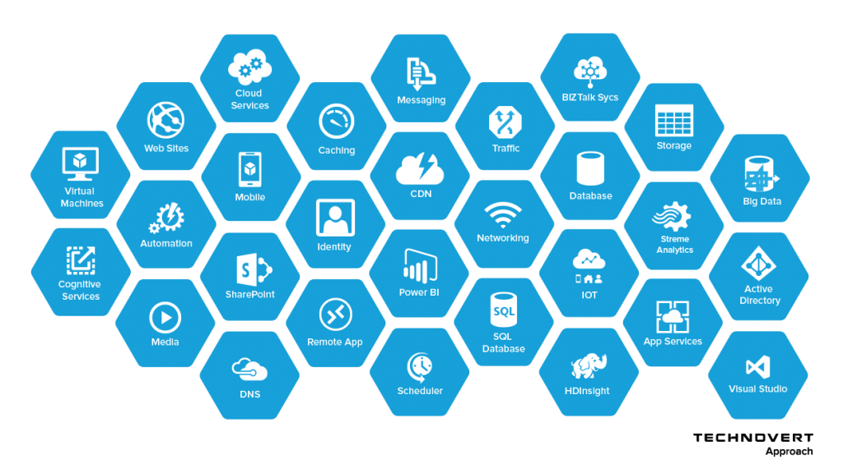

Figure 3: Azure services

Curated List of Top Azure Services

While there is no long list of competitors in cloud servicing, the top runners like Google and AWS continue to give a tough fight to Microsoft Azure in the race of being the most used cloud service. Despite intense competition, Microsoft Azure continues growing and evolving over the years, especially through the phase of remote working due to a pandemic in 2020 and 2021. Offering **top Azure services**, the platform has maintained its integrity and popularity. Now let’s delve deeper into understanding more about the top 10 most popular Azure services.

Azure Active Directory

[Azure Active Directory (AD)](https://www.whizlabs.com/blog/what-is-azure-active-directory-all-that-you-should-know/) is one of the most popular cloud computing services from Microsoft Azure. Belonging to the Identity section, it is a universal identity platform to ensure the management and security of identities. It deserves the topmost mention in our list of best **Azure services**because of its robust security solutions. Azure Active Directory offers single sign-on and multi-factor authentication as an enterprise identity service to protect them from cybersecurity threats. Identity-based security ensures complete safeguarding of the users as well, against cyberattacks. They can access the software from any corner of the world through authenticated login. As Azure Active Directory creates a single identity platform, it is also easier to have secure engagement with internal and external users.

Azure CDN

[Azure Content Delivery Network (CDN)](https://www.whizlabs.com/blog/azure-cdn-complete-guide/) deserves a mention here for being an extremely important **Azure service** that enables and accelerates growth in businesses. Its server is designed in a way that it can integrate a lot of storage space, web apps, and Azure cloud services. This is why Azure CDN is used to deliver content securely all across the world.

Azure CDN is right at par with the top **Azure services**due to its high response speed and low load time. It also comes laced with heavy security so that the developers don’t have to spend enough time on developing new security solutions every time they share any content. This data is also further disintegrated into minute customer workflows with actionable engagement insights, thus profiting the enterprise.

Azure Data Factory

To create a data-driven workflow in cloud computing, Azure Data Factory ingests data from several sources to automate data transmission and movement. Azure Data Factory utilizes several **Azure services**for computing like – Azure Machine Learning, Azure HDInsight Hadoop, and Azure Data Lake Analytics. Azure Data Lake can be understood as a huge repository of data in its original form for Big data analytics.

Output data from Azure Data Factory can be published on Azure Data Lake for Business Analytics (BI) applications for analytics and visualization. Azure Data Factory deserves a mention in the **top Azure services**as it does not store any data but allows you to gauge the movement of data and determine a data-driven workflow. By utilizing the raw data through data stores, better business decisions can be taken. Using UI and programmatic mechanisms, Azure Data Factory creates and monitors workflows.

Azure SQL

Azure SQL database comes under the category of the platform as a service (PaaS) and is related to most of the database management functions, like – backups, monitoring, patching, and upgrading without any kind of user involvement. The efficiency of Azure SQL without requiring any human intervention is the reason why we have to mention it in our list of **top Azure services.**

The Azure SQL database brings integrated PaaS capabilities helping you administer domain-specific databases and optimize the activities as per your business needs. The Azure SQL database is always upgraded to the latest and stable version of the SQL server database engine. It is accompanied by a patched OS with 99.99% availability.

If your business deals with both relational and non-relational data structures like JSON, Spatial, graphs, and XML, then Azure SQL database can be one of the best **Azure services**for processing both kinds of data structures. For modern cloud applications, the Azure SQL database adds a readily available data storage facility with enhanced performance for enterprises.

Azure Function

Developers use Azure Functions to connect to data sources or messaging solutions and react to events. The best part about Azure Function is its compute-on-demand capacity which means that you only pay for the services when you consume the resources. Azure Functions, a serverless compute service, enables enterprises to run event-triggered codes without having an infrastructure for its provision.

Azure Function is greatly reliable and is used in production settings. It can be used to achieve decoupling, high-throughput, shared, and reusability.

CosmosDB

One of the most celebrated **Azure services,**[CosmosDB](https://www.whizlabs.com/blog/azure-cosmos-db-a-complete-guide/" \t "_blank) is a globally distributed database service. It can access and manage data from scattered data centers while offering tools to scale up your computation resources and global distribution patterns through Microsoft Azure.

Interestingly, CosmosDB ensures 99.99% availability while restricting read and write latencies to single-digit milliseconds. It also supports multiple data models through a single backend – and thus, can be used for graph models, key-value, relational models, and documents. CosmosDB is a **top Azure service**widely regarded as a NewSQL database, but it stays distinct with its inability to process-relational data models.

DevOps

As you start using Microsoft **Azure services**, the software as a service (SaaS) platform of DevOps will be needed to develop and deploy software. It offers easy integration facilities with famous tools in the industry and can help orchestrate a DevOps toolchain. DevOps services prove the agility of the tools by tracking, planning, and discussing their work among other teams.

For most of the users, DevOps are greatly beneficial to their applications, irrespective of the platform, language, or cloud. They also enable faster delivery through active planning and better collaboration. Using the efficient tools, this **Azure service**ensures an access to unlimited, cloud-hosted private Git repository where the application coding welcomes collaboration with advanced file management.

Azure Backup

Human error is a crude reality and **Azure Backup**allows simple data protection tools from the Azure Web app services, to keep your data protected from ransomware or loss of any kind. The backup cost is almost inexpensive, and can be used for backing up SQL workloads, as well as data from virtual machines too.

Tools like Windows VSS Snapshot and Linux fsfreeze can come in handy along with Azure Backup to maintain consistency in the data. The backup system of Azure enables better task management and project efficiency.

Logic Apps

As one of the **top Azure services**, Logic Apps have gained immense popularity due to their useful and efficient tools. They can offer effective solutions to integrate different applications. One must note the tightly-knit ecosystem of cloud-based SaaS connectors like Google Services, Twitter, and Office 365. Logic apps make it very easy for Electronic Data Interchange (EDI) standards to operate in collaboration with trading partners through their B2B functionalities. Logic apps can also virtually connect devices, data, and apps across different locations.

Virtual Machine

A virtual machine is generally called an image, a file that can behave like an actual computer. Microsoft Azure offers the addition of virtual machines in its Compute category, thus creating Windows or Linux systems within a few seconds on a physical computer. The virtual machine stays separate from the rest of the computer, thus providing a perfect space to test beta applications, access virus-infected data, create system backups and run applications that were not natively intended to be run on the given operating system.

Using Hypervisor’s management, Microsoft Azure also enables running multiple virtual machines on the same physical computer. Each virtual machine has its own virtual hardware along with specifications for CPU, memory, hard drive, network, etc. Virtual Machines can reduce the cost of investing in physical machines along with the added maintenance cost, power charges, and cooling facilities.

**5.IBM**

Cloud Computing

IBM computing and services are distributed – but not limited to – three main fields of high computing solutions, including:

* Bare metal servers, virtual cloud servers, dedicated mass storage servers, and SAP Certified infrastructure.
* VMware solutions to enable migrating from on-premise.
* Container registry with Docker container, Kubernetes service, and Serverless platform Functions.

Cloud Networking

IBM Cloud Networking gives you a high-performance bouquet of services, which include:

* Public, private, hybrid networks.
* Load balancers, firewalls, and VPN tunnels.
* Content delivery network (CDN).
* Secure encrypted data network.
* Integrating cloud and on-premises systems by App Connect and IBM Secure Gateway.

Cloud Storage

IBM cloud storage is not only for files; it provides scalable, highly secure, and low-cost options, including database and storage of Big Data, to make it easier to deploy services such as:

* Access objects storage solutions for SQL and NoSQL.
* Block storage, and NFS-based file-share solution up to 12 TB.
* File storage NFS-based file-share solution that scalable and backed by flash.
* Document store Cloudant to process heavy loads concurrent for NoSQL JSON.

Cloud Analytics and Developer Tools

IBM Cloud provides core Analytics services and solutions that enable you to analyse, track events, and monitor all of your analysing needs, from security to products. The IBM Bluemix cloud also contains an analytics engine mixed with Apache Spark & Hadoop services, especially suitable for hybrid cloud options.

For developers, some consider IBM Cloud a paradise in terms of workspaces. Programmers are known to have an efficient deployment of code in less time than normal. Carrying out Continuous Integration, deployment, and delivery processes is easier, thanks to the ability to make analytics and analysis on streaming data.

Artificial Intelligence (AI), Machine Learning, IoT, and Mobile

IBM’s AI Watson is well known as one of the most amazing machine learning APIs ever created; it provides many AI-based innovations. in addition to running IoT backends, this technology includes the following:

* Virtual assistants.
* Text to speech.
* Visual recognition.
* Natural language processing.
* Deep learning.
* Manage analytics on the data ingested from IoT devices.
* IBM Weather API 5.
* Building mobile applications and their back-end components.
* Providing IBM’s Blockchain Platform to develop Blockchain apps.

Management and Security

IBM Cloud Includes (and provides) many tools and services for active management and tracking of all resources for management, administrative, security, and financial aspects. This is achieved using log analysis, automation, Infrastructure as Code (IaC), identity and access management, and advanced authentication solutions.

**6.Salesforce**

**Sales Cloud**

[Sales Cloud](https://www.demandblue.com/salesforce-sales-cloud-implementation/), one of the most popular Salesforce products refers to the “sales” module in salesforce.com. It is about identifying, selling, and managing your prospects and customers to reach your sales objectives. It includes Leads, Accounts, Contacts, Contracts, Opportunities, Products, Price books, Quotes, and Campaigns.

**Service Cloud**

Service Cloud is a Salesforce application to support every customer, anytime, anywhere. [Salesforce Service Cloud](https://www.demandblue.com/salesforce-service-cloud-features/) is the world’s #1 customer service solution which provides agents the tools to quickly manage customer cases using consoles, communities, knowledge bases, collaboration, social service and multichannel support features.

**Marketing Cloud**

[Salesforce Marketing Cloud](https://www.demandblue.com/salesforce-marketing-cloud-implementation/) was previously known as ExactTarget, which is the digital marketing arm of the Salesforce product family. This is one of most sought-after Salesforce products by digital marketers that enables them to create personalized, one-to-one email communications to drive better customer engagement and marketing ROI (Return on Investment). Salesforce Marketing Cloud (ExactTarget) helps build better customer journeys and enhance customer engagement with a brand across channels outside of email as well including web, mobile, social and ads.

**Experience Cloud**

[Experience Cloud](https://www.demandblue.com/salesforce-experience-cloud/) previously known as Community Cloud is a cloud service model that provides a cloud computing solution to a limited number of individuals or organizations that is governed, managed and secured commonly by all the participating organizations or a third party managed service provider. In a community cloud, infrastructure is shared by several organizations and supports a specific community that has shared concerns (e.g., mission, security requirements, and policy or compliance considerations). When organizations share a computing infrastructure within the same community it is termed as community cloud.

**Analytics Cloud**

Cloud analytics is a type of cloud service model where data analysis and related services are performed on a public or private cloud. Cloud analytics can refer to any data analytics or business intelligence process that is carried out in collaboration with a cloud service provider.

**App Cloud**

Application Cloud is an application program that functions in the cloud, with some characteristics of a pure desktop app and some characteristics of a pure Web app. A desktop app resides entirely on a single device at the user’s location (it doesn’t necessarily have to be a desktop computer). A Web app is stored entirely on a remote server and is delivered over the Internet through a browser interface.

**IoT Cloud**

IoT (Internet of Things) is a hot topic among the Salesforce Products today which is going to provide a lot of opportunities with a lot of challenges. IoT is a giant network of connected things. It’s a connection between people-thing, thing-thing, and thing –people. IoT is the technology which connects the people and all the possible things in the world to make human life easier. [Salesforce IoT Cloud](https://www.demandblue.com/salesforce-iot-cloud-2/) mainly focuses on transforming connected devices into useful customer data. The platform uses the data harvested from devices to enrich the customer interactions proactively in real time.

**7.ORACLE**

Services

Infrastructure as a Service (IaaS) and Platform as a Service (PaaS)

Oracle's cloud infrastructure was made generally available (GA) on October 20, 2016 under the name "Oracle Bare Metal Cloud Services." Oracle Bare Metal Cloud Services was rebranded as Oracle Cloud Infrastructure in 2018 and dubbed Oracle's "Generation 2 Cloud" at Oracle OpenWorld 2018. Oracle Cloud Infrastructure offerings include the following services:

Compute

* The company provides Virtual Machine Instances to provide different shapes (VM sizes) catering to different types of workloads and performance characteristics. They also provide on-demand Bare metal servers and Bare metal GPU servers, without a hypervisor. In 2016, Oracle Cloud Infrastructure launched with bare metal instances with [Intel processors](https://en.wikipedia.org/wiki/Intel_processors). These first base metal instances offered were powered by Intel servers. In 2018, Oracle Cloud added bare metal instances powered by [AMD processors](https://en.wikipedia.org/wiki/AMD_processors), followed by [Ampere Cloud Native ARM](https://en.wikipedia.org/wiki/Ampere_Computing) processors in 2021. In 2021, Oracle also released its first VM-based compute instances based on Arm processors.

Storage

* The platform provides block volumes, file storage, object storage, and archive storage for database, analytics, content, and other applications across common protocols and APIs.

Networking

* This cloud platform provides network with fully configurable IP addresses, subnets, routing, and firewalls to support new or existing private networks with end-to-end security.

Governance

* For auditing, identity and access management, the platform has data integrity checks, traceability, and access management features.

Database Management / Data Management

* Oracle offers a data management platform for database workloads as well as hyper-scale [big data](https://en.wikipedia.org/wiki/Big_data) and streaming workloads including OLTP, data warehousing, [Spark](https://en.wikipedia.org/wiki/Apache_Spark), [machine learning](https://en.wikipedia.org/wiki/Machine_learning), text search, image analytics, data catalog, and [deep learning](https://en.wikipedia.org/wiki/Deep_learning). The platform allows [Oracle](https://en.wikipedia.org/wiki/Oracle_Database), [MySQL](https://en.wikipedia.org/wiki/MySQL), and [NoSQL](https://en.wikipedia.org/wiki/NoSQL) databases to be deployed on demand as managed cloud services. Oracle Databases uniquely offer the Oracle Autonomous Database (optimized for data warehouse, transaction processing, or JSON), the [Exadata](https://en.wikipedia.org/wiki/Exadata) shape, as well as Real Application Clusters (RAC).

Load Balancing

* The cloud platform offers load balancing capability to automatically route traffic across fault domains and availability domains for high availability and fault-tolerance for hosted applications.

Edge Services

* These services can monitor the path between users and resources and adapt to changes and outages using secure DNS infrastructure.

FastConnect

* The cloud platform provides private connectivity across on-premises and cloud networks through providers like [Equinix](https://en.wikipedia.org/wiki/Equinix), [AT&T](https://en.wikipedia.org/wiki/AT%26T), and [Colt](https://en.wikipedia.org/wiki/Colt_Technology_Services).

[Application Development](https://en.wikipedia.org/wiki/Oracle_Cloud_Platform#Application_Development)

* For application development, the company’s cloud offers an open, standards-based application development platform to build, deploy, and manage API-first, mobile-first cloud applications. This platform supports container-native, cloud-native, and low code development. This platform also provides a DevOps platform for [CI/CD](https://en.wikipedia.org/wiki/CI/CD), diagnostics for Java applications, and integration with SaaS and on-prem applications. Services include Java, mobile, digital assistants (evolution from chatbots), messaging, application container cloud, developer cloud, visual builder, API catalog, AI platform, DataScience.com (Oracle acquired) and blockchain.

Software as a Service (SaaS)

Oracle provides SaaS applications also known as Oracle Cloud Applications. These applications are offered across a variety of products, industrial sectors with various deployment options to adhere to compliance standards. The below list mentions Oracle Cloud Applications provided by [Oracle Corporation](https://en.wikipedia.org/wiki/Oracle_Corporation).

* [Customer Experience](https://en.wikipedia.org/wiki/Oracle_Advertising_and_Customer_Experience_(CX)) (CX)
* [Human Capital Management](https://en.wikipedia.org/wiki/Oracle_HCM_Cloud) (HCM)
* [Enterprise Resource Planning](https://en.wikipedia.org/wiki/Oracle_Enterprise_Resource_Planning_Cloud) (ERP)
* [Supply Chain Management](https://en.wikipedia.org/wiki/Supply_Chain_Management) (SCM)
* Enterprise Performance Management (EPM)
* [Internet of Things](https://en.wikipedia.org/wiki/Internet_of_Things) Applications (IoT)
* SaaS Analytics
* Data
* Industry Solutions (Communications, Financial Services, Consumer Goods, High Tech and Manufacturing, Higher Education, Hospitality, Utilities)
* Deployment (adhering to standards for sectors such as Financial Services, Retail Services, Public Sector, Defense)
* Block-Chain Cloud Service (in partnership with [SAP](https://en.wikipedia.org/wiki/SAP_SE), [IBM](https://en.wikipedia.org/wiki/IBM) and [Microsoft](https://en.wikipedia.org/wiki/Microsoft_Windows))
* Blockchain Applications

On July 28, 2016 Oracle bought [NetSuite](https://en.wikipedia.org/wiki/NetSuite), the very first cloud company, for $9.3 billion.

**Submitted By:**

**Amogh Garg**

**2020UCO1688**